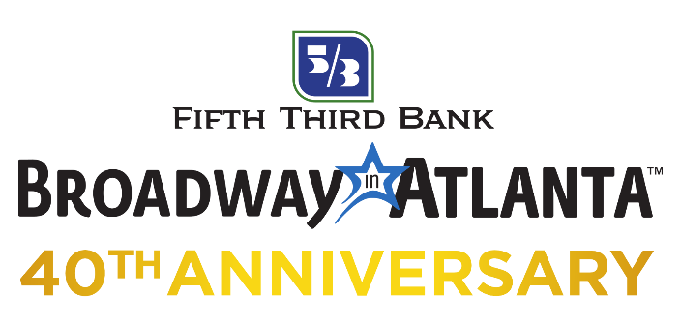

For More Information
BRAVE Public Relations / 404.233.3993
broadway@emailbrave.com
FOR IMMEDIATE RELEASE

BROADWAY TO RETURN TO ATLANTA IN 2021

HAMILTON to return as part of the Fifth Third Bank Broadway in Atlanta 40th Anniversary Season at the Fox Theatre

Subscription packages on sale now

ATLANTA (April 19, 2021) – Fifth Third Bank Broadway in Atlanta has announced that Broadway performances are scheduled to recommence at the Fox Theatre in August, 2021, featuring the anticipated return of HAMILTON. Also slated for the upcoming 40th Anniversary season are FIDDLER ON THE ROOF, TOOTSIE, AIN’T TOO PROUD – THE STORY OF THE TEMPTATIONS, JESUS CHRIST SUPERSTAR, Disney’s FROZEN and MEAN GIRLS. Dr. Seuss’ HOW THE GRINCH STOLE CHRISTMAS! MUSICAL, BLUE MAN GROUP and BEAUTIFUL – THE CAROLE KING MUSICAL are available as season options.

“We’re greatly optimistic about the return of Broadway to the city of Atlanta and thrilled to share the news that shows previously announced for the 40th Anniversary season will remain available to patrons under a revised schedule,” said Vice President of Broadway in Atlanta Russ Belin. “We are thankful to our patrons for their patience, flexibility and love of Broadway, which has been an incredible support and inspiration during this extended intermission. We look forward to welcoming theatergoers back to the Fox Theatre in 2021 for what is expected to be an unforgettable season and the long-awaited return of Broadway.”

Broadway in Atlanta is actively working alongside our colleagues at the Fox Theatre, and in collaboration with state and local government officials, to re-open following local, state and federal health guidelines. Additional information about the venue’s enhanced health and safety measures can be found on the Fox Theatre website. The health and well-being of audiences, touring productions, staff and all venue personnel remains top priority. Once approval is received on a re-opening plan, additional details will be shared with theatregoers. Should there be additional changes and/or cancellations, subscribers will be notified immediately, and the value of their ticket will be safe. They may receive a credit, refund or the option to donate the value of their tickets to Broadway Cares.

The revised Fifth Third Bank 2021-2022 Broadway in Atlanta season subscription package includes:
FIDDLER ON THE ROOF November 9 – 14, 2021
TOOTSIE January 25 – 30, 2022
AIN’T TOO PROUD – THE LIFE AND TIMES OF THE TEMPTATIONS March 8 – 13, 2022
JESUS CHRIST SUPERSTAR April 19 – 24, 2022
Disney’s FROZEN June 2 – 12, 2022
MEAN GIRLS July 19 – 24, 2022

Additional show options that can be added to a season subscription include:
HAMILTON August 24 – Sept 26, 2021
Dr. Seuss’ HOW THE GRINCH STOLE CHRISTMAS! MUSICAL December 7 – 12, 2021
BEAUTIFUL – THE CAROLE KING MUSICAL May 20 – 22, 2022
BLUE MAN GROUP July 8 – 10, 2022

All current subscribers have been contacted directly about their subscriptions to the Fifth Third Bank Broadway in Atlanta Season. New subscriptions are currently on-sale. For more information please visit atlanta.broadway.com/subscriptions.

For immediate news updates and further announcements, connect with Broadway in Atlanta on Facebook and Instagram.
###

Broadway Across America (BAA) is part of the John Gore Organization family of companies, which includes Broadway.com, The Broadway Channel, BroadwayBox.com and Group Sales Box Office. Led by 14-time Tony-winning theater producer John Gore (Owner & CEO), BAA is the foremost presenter of first-class touring productions in North America, operating in 47 markets with over 400,000 subscribers. Presentations include Disney’s The Lion King, Wicked, The Book of Mormon, The Phantom of the Opera and Hamilton. Current and past productions include Ain’t Too Proud, Beautiful, Cats, Chicago, Dear Evan Hansen, Mean Girls, Moulin Rouge! and To Kill A Mockingbird.

The John Gore Organization is the leading developer, producer, distributor and marketer of Broadway theatre worldwide. Under the leadership of 14-time Tony-winning theater producer and owner John Gore, its family of companies includes Broadway Across America, Broadway.com, The Broadway Channel, BroadwayBox.com and Group Sales Box Office. The company presents shows in 47 cities across North America as well as on Broadway, Off-Broadway, London’s West End, Japan, and China. It has won Tony Awards in every producing category as well as numerous other Drama League, Drama Desk and Olivier awards.

